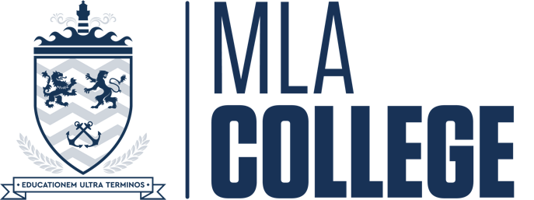

MLA College Complaints Form
Early Resolution Stage

Please use this form to lodge a complaint at the Early Resolution Stage in line with the University of Plymouth’s Complaints Procedure which also applies to its partner institutions (MLA College being a partner institution of the University of Plymouth) and which can be found here.

You are expected to make the complaint yourself but in exceptional situations you can ask a relative or supporter to make a complaint on your behalf. You must give your explicit written consent for someone to do so.

Personal information
First name *

Surname *

Student reference number *
Programme
Stage of study (year 1, year 2, etc.)

Your complaint

Are you submitting a complaint on behalf of a group? | Yes/No
What is your complaint? *
What action have you taken already to resolve your complaint? *
What response have you received? *
What is it about this response that is not satisfactory? *
What outcome do you wish your complaint to achieve at the Early Resolution Stage?
Provide any other information about your case that might be important.

Please return this form to: student.support@mla.ac.uk

